**Homework 7. Solutions**

Teacher: Paul Briard

Ex. 1.

A guitar string lies along the x-axis when in equilibrium. The end of the string at $x=0$ (the bridge of the guitar) is fixed. A sinusoidal wave (y-displacement) with amplitude $A=0.750 mm=7.50×{10}^{-4}m$ and frequency $f=440 Hz$, travels along the string in the – $x$-direction at velocity $v=143 m.s^{-1}$. It is reflected from the fixed end, and the superposition of the incident and reflected waves forms a standing wave, as shown on the figure for the case of the forth harmonic (it could be any other harmonic, of course). (a) Find the equation giving the displacement $y\left(x,t\right)$ of a point on the string as a function of position and time (in SI units, they must have been shown on the equation). (b) Locate the nodes (describe their x-location, unit: m, position of the 4 first nodes is sufficient) . (c) Find the amplitude of the standing wave $A_{SW}$ (unit: m) and the maximum value of the transverse velocity $v_{y}(x,t)$, which occurs at the antinodes (unit: $m.s^{-1}$). When occurs the maximum transverse velocity of any point of the string ? (excepted at the nodes which have always zero transverse velocity).

About the description of $y\left(x,t\right)=A_{SW}\sin\left(kx\right)\sin{(ωt)}$ for the standing wave, you don’t need to demonstrate it and can just use this result (you have to calculate what is inside it).

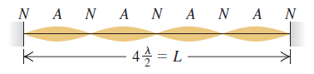

**Solution**

(a)

The angular frequency is: $ω=2πf=\left(2π rad\right)\left(440 s^{-1}\right)=2765 rad.s^{-1}$

The wave number is:

$$k=\frac{ω}{v}=\frac{2765 rad.s^{-1}}{143 m.s^{-1}}=19.3 rad.m^{-1}$$

The amplitude of the standing wave is:

$$A_{SW}=2A=1.50×{10}^{-3}m$$

The y-displacement for the standing wave is:

$$y\left(x,t\right)=A_{SW}\sin{(kx)}\sin{(ωt)}$$

We obtain:

$$y\left(x,t\right)=\left(1.50×{10}^{-3}m\right)\sin\left[\left(19.3 rad.m^{-1}\right)x\right]\sin\left[\left(2765 rad.s^{-1}\right)t\right]$$

b) The figure where there are 5 nodes was just an example. There could be more or less nodes (it depends to the length of the string).

The position of the nodes are:

$$x=0,\frac{λ}{2},λ,\frac{3λ}{2}, …$$

The wavelength is such as:

$$λ=\frac{v}{f}=\frac{(143 m.s^{-1})}{(440 s^{-1})}=0.325 m$$

The positions of the nodes are:

$$=0,0.163 m,0.325 m,0.488 m, …$$

The transverse y-velocity is described by:

$$v_{y}\left(x,t\right)=\frac{∂y(x,t)}{∂t}$$

“ $∂$” means “partial derivative”. Here $x$ is seen as a constant for the calculation of $v_{y}\left(x,t\right)$.

$$v_{y}\left(x,t\right)=\frac{∂}{∂t}\left[A_{SW}\sin{(kx)}\sin{(ωt)}\right]$$

$$v_{y}\left(x,t\right)=A_{SW}\sin{(kx)}\frac{∂}{∂t}\left[\sin{(ωt)}\right]$$

$$v_{y}\left(x,t\right)=ωA_{SW}\sin{(kx)}\cos{(ωt)}$$

At an antinode, $\sin{(kx)}=±1$, i.e. the y-velocity varies between $v_{y}=ωA_{SW}=4.15 m.s^{-1}$ and $v_{y}=-ωA_{SW}=-4.15 m.s^{-1}$

The maximum transverse velocity of any point (excepted at the nodes, where the transverse y-velocity is always zero) of the string occurs when the string is at equilibrium position (as for any SHM).

Ex. 2. The sound propagates in air at the velocity $≈344 m.s^{-1}$. (a) **Audible wavelengths**. The range of audible frequencies is from about 20 Hz to 20,000 Hz. What is the range of the wavelengths of audible sound in air? (for the smallest wavelength, unit: cm, for the longest wavelength, unit: m) (b) **Brain surgery**. Surgeons can remove brain tumors by using a cavitron ultrasonic surgical aspirator, which produces sound waves of frequency 23 kHz. What is the wavelength of these waves in air? (unit: cm) (c) **Sound in the body.** What would be the wavelength of the sound in part (b) in bodily fluids in which the speed of sound is 1480 $m.s^{-1}$ but the frequency is unchanged? (unit: cm)

**Solution:**

a)

The sound wave propagates at the velocity $v=344 m.s^{-1}$.

For the frequency $f=20000 s^{-1}$, the wavelength is:

$$λ=\frac{v}{f}=\frac{344 m.s^{-1}}{20000 s^{-1}}=0.017 m=1.7 cm$$

For the frequency $f=20 s^{-1}$, the wavelength is:

$$λ=\frac{v}{f}=\frac{344 m.s^{-1}}{20 s^{-1}}=17 m$$

The range of wavelength of the audible sound by human ear is between 1.7 cm and 17 m.

(b) The cavitron ultrasonic generator produce sound waves of frequency $23×{10}^{3} s^{-1}$. The corresponding wavelength for a sound wave propagating in air is:

$$λ=\frac{v}{f}=\frac{344 m.s^{-1}}{23×{10}^{3} s^{-1}. }=0.015 m=1.5 cm$$

(c)

In a body fluid where the sound wave propagates at velocity $v=1480 m.s^{-1}$, the wavelength is:

$$λ=\frac{v}{f}=\frac{1480 m.s^{-1}}{23×{10}^{3} s^{-1}. }=0.064 m=6.4 cm$$

Ex. 3.

A fisherman notices that his boat is moving up and down periodically, owing to (sinusoidal)waves on the surface of the water. It takes 2.5 s for the boat to travel from its highest point to its lowest, a total distance of 0.62 m. The fisherman sees that the wave crests are spaced 6.0 m apart. (a) How fast are the waves traveling? (b) What is the amplitude of each wave? (c) If the total vertical distance traveled by the boat were 0.30 m but the other data remained.

**Solution:**

(a)

The period of the sinusoidal wave is:

$$T=2\left(2.5 s\right)=5.0 s$$

The wavelength of the wave is $λ=vT=6.0 m$

We obtain the velocity of propagation of the wave:

$$v=\frac{λ}{T}=\frac{6.0 m}{5.0 s}=1.2 m.s^{-1}$$

(b)

The amplitude of the wave is:

$$A=\frac{0.62 m}{2}=0.31 m$$

(c) The amplitude become $A=0.15 m$. The wavelength, the period and the wave speed are unchanged.

Ex. 4. A certain transverse wave is described by

$$y\left(x,t\right)=\left(6.50 mm\right)\cos{2π\left(\frac{t}{0.0360 s}-\frac{x}{28.0 cm}\right)}$$

Determine the wave’s (a) amplitude; (b) wavelength; (c) frequency (d) speed of propagation; (e) direction of propagation(you don’t have to use SI units, you can choose what is the most convenient according to what you see).

**Solution:**

The wave is described by the equation $y\left(x,t\right)=Acos (ωt-kx)$

(a)

The amplitude of the wave is: $A=6.50 mm$

(b)

The wave number $k=2π/λ$, thus the wavelength of the wave is: $λ=28.0 cm$.

(c)

The angular frequency is $ω=2πf=2π/T$ where $T=0.0360 s$ is the period of the wave, thus the frequency is:

$$f=\frac{1}{0.0360 s}=27.8 Hz$$

The unit of the frequency Hz means “ $s^{-1}$”.

(d) The velocity of propagation of the wave is:

$$v=\frac{λ}{T}=\frac{0.28 m}{0.0360 s}=7.78 m.s^{-1}$$

(e) The wave propagates toward the +x-direction.

**Ex. 5. Superposition of two triangular pulses**

The figure shows two triangular wave pulses on a stretched string traveling toward each other. As for the superposition of sinusoidal waves, the net displacement is the algebraic sum of the displacement corresponding to each pulse. Each pulse is traveling with a speed of $2.0 cm.s^{-1}$ and has the height and width shown in the figure. If the leading edges of the pulses are 1.00 cm apart at time $t=0 ,$ sketch the shape of the string at t = 0.250 s, t = 0.750 s, t= 1.000 s and t = 1.250 s.

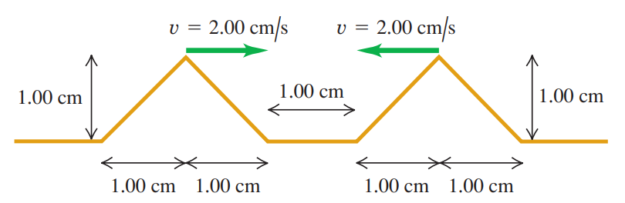

**Solution:**

At t = 0.250 s:

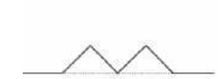

At t = 0.500 s: (not asked in the exercise, but can help to understand)

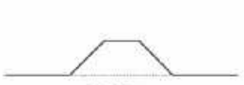

At t = 0.750 s:

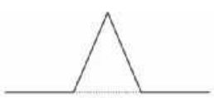

At t = 1.000 s:



At t = 1.250 s:

